Renju lesson on January 18, 2001

Hello all! Welcome to Online Renju Class.
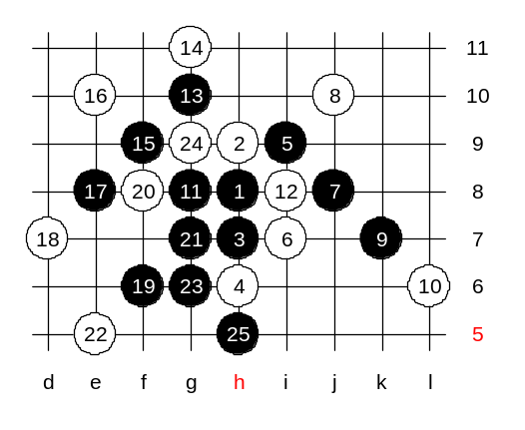
In past weeks we have learned about the strongest 5th move in d8 opening. It is time to take a look at other 5th moves in this opening. We will start learning the most popular 5th move. I am sure everyone knows it. Yes, it is i9. You must also keep in mind that the edge distance influences the 5-i6 in many cases although i6 and i9 are symmetrical. Lets begin with 5-j9. I have a question for you. Can white play any 6th move other than 6-g7? The answer is – there are no other 6th moves. Lets select one “wrong” 6th move and try to find black’s winning plan. OK, we try 6-i7. You can select the white blocks. As you see, black has a very good potential for attack in case of such 6th move.

I think we can continue with the correct 6th move now. Yes, it is g7.
Now, where is the next black move? Everybody says f8. Everybody says f8 because theory says so. How about i8? Why cannot black play i8? I8 creates three open pairs whereas f8 creates only one. Can anyone explain why?
Lets try it out. That way it is easier to explain. White plays 8-g6. Now it is time for conclusions. White has blocked one of black’s three pairs. White has 3 pairs of its own now, and the rest of two black pairs are under white’s control. In such case, white advantage is very clear. Black should have played 7-f8 and block one of the white lines, and although it creates only one black line, black keeps the domination and control over the position. Remember, the control over the position is far more important than having many lines. Just in order to prove the weakness of 7-i8, lets continue this diagram and play it to the end. 9-g8 is the best resistance. Thinking about 14th move, you must be careful. You must be active enough to keep the initiative, at the same time not let black develop counter-attack. How to play the white move so that it attacks and at the same time controls black structures? There are two main ideas – to play actively below and try to control the black structures remotely, or to play simply to j8 and block everything at once. I evaluate the situation like this: If I can play actively below, then I would choose the active move. While considering the activity of the move and controls over black’s actions, I must also consider that black may in his turn control white instead, and white would be in trouble.
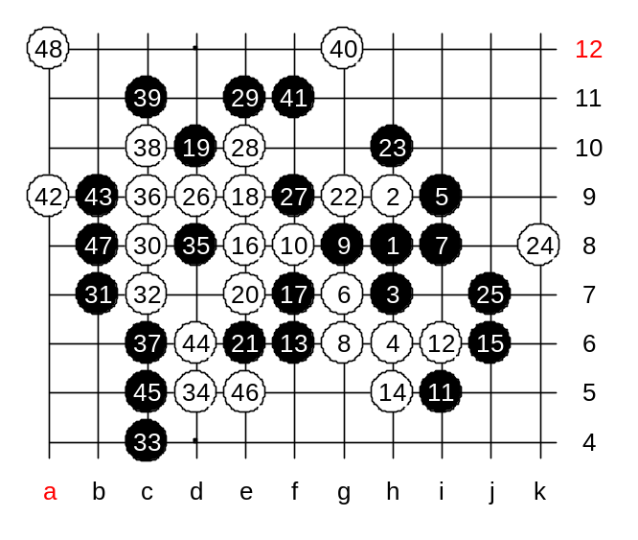
Lets think about h5 for a moment. White sure has an activity and control as well. The only question is, can black play a move which in its turn controls white and develops black structures. Lets test h5, then we will see clearly what will happen.
Black’s attack is out of question. If black plays i10 then white blocks from i7 and black attack fails whereas white is even more powerful. So, black has to defend. Which defense move is the best in your opinion? Ok, we play f6.
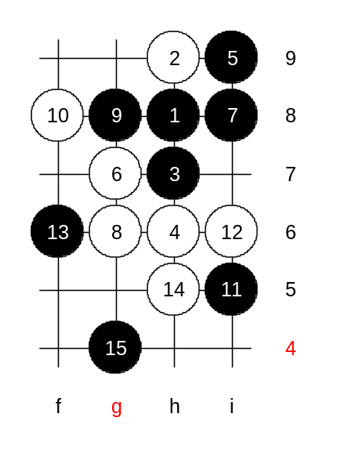
Well, white won very nicely here.

I give you the medium level homework position now. Please write it down, and do not comment the position here in class. This is your homework. Find the white win after black’s 15-g4.

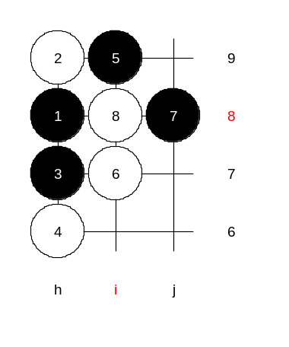

This is the advanced level homework. Please find the black win.

The lesson is over now. Thank you all for coming, and see you next week! For all Chinese I wish happy coming new year!

